2m 50Ohm ARDF antenna
by White Fossa aka Artyom Vetrov.
License: AGPLv3+

1) Cut a pair of 2mm lacquer covered copper wires to 49 cm, bend 1cm end to 90 degrees.
2) Remove lacquer at the bent end tips.
3) Print antenna base and a pair of tip protectors (ABS, 20% honeycomb infill).
4) Glue the wires to the base with a hot glue:
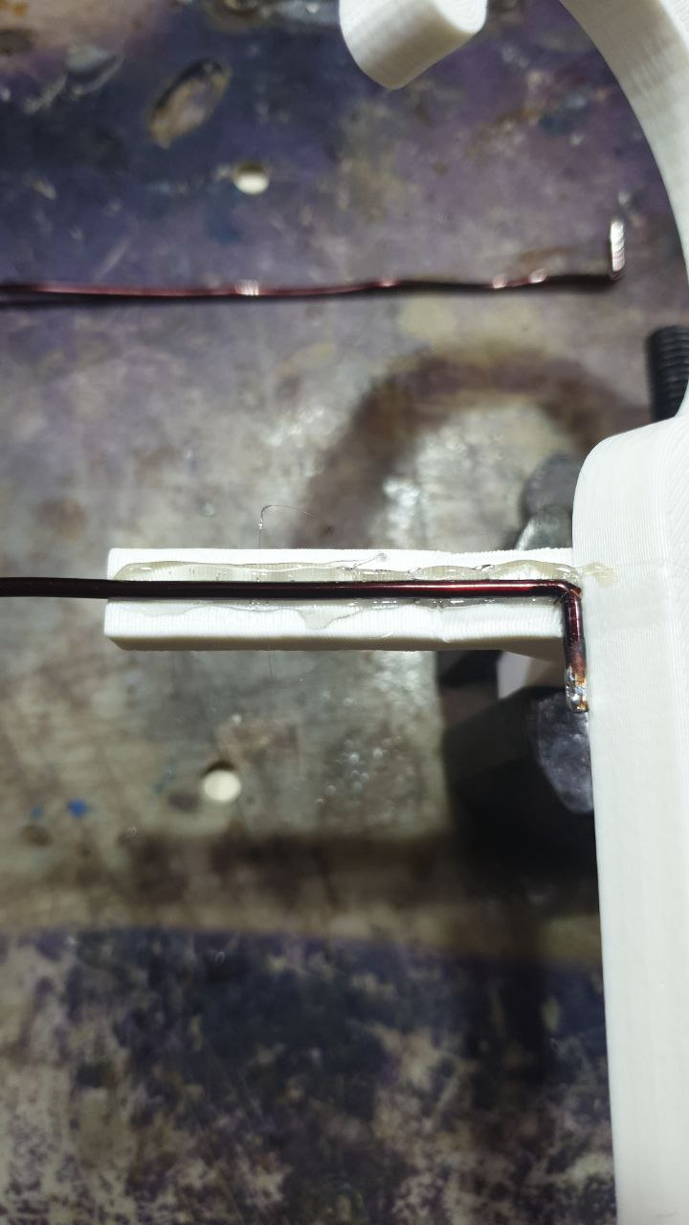
5) Secure them additionally with insulating tape:
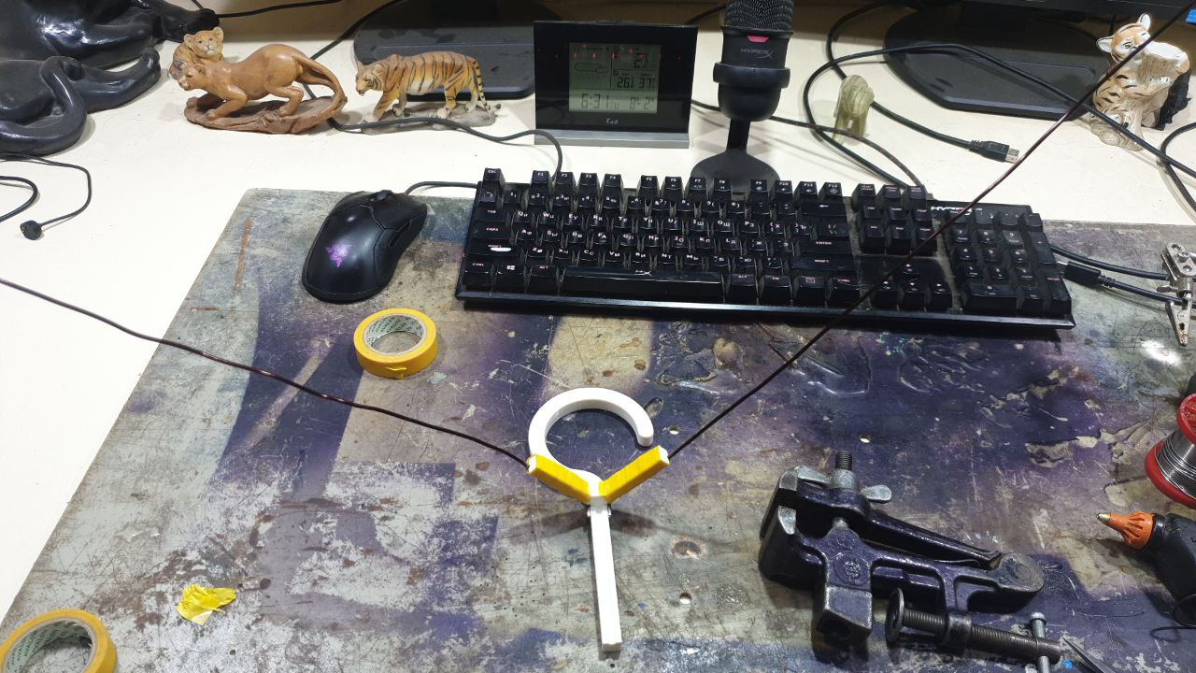
6) Solder the cable to wires and glue it to base using hot glue too:
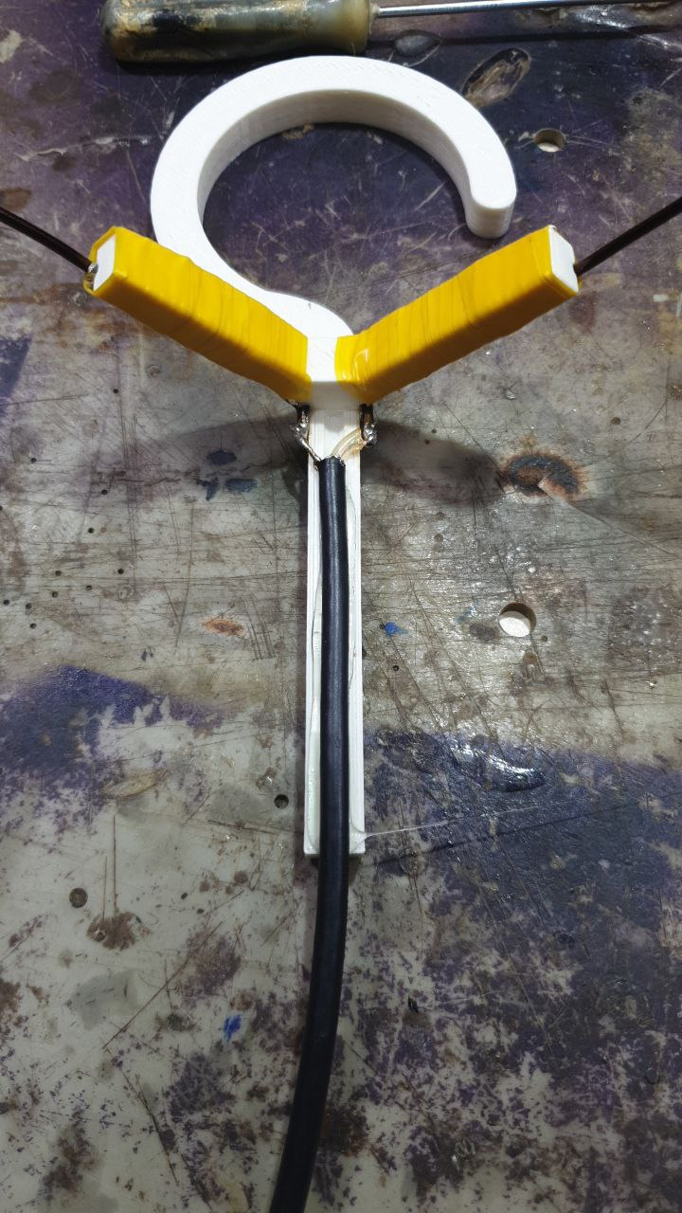
7) Secure it with the insulating tape.
8) Heat other ends of wires and insert it into protectors while hot.
9) Done:
